Results on beans

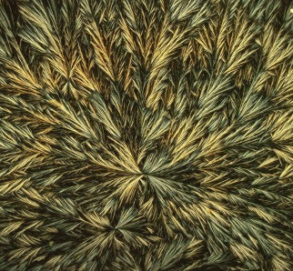 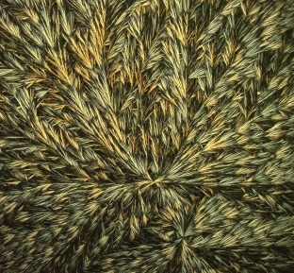 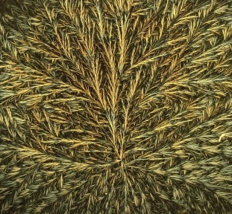 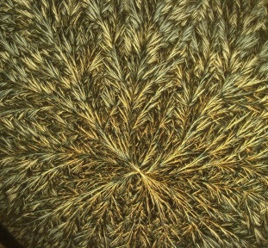

Bean1 (b1) Bean2 (b2) Bean3 (b3) Bean4 (b4)

1. **Calculation multifractal spectra by using density function**

Bean1

|  |  |
| --- | --- |
|  | mfs |
| 1.16 | 0.52 |
| 1.41 | 0.94 |
| 1.66 | 1.44 |
| 1.91 | 1.67 |
| 2.16 | 1.43 |
| 2.41 | 1.06 |
| 2.66 | 0.73 |
| 2.91 | 0.48 |
| 3.16 | 0.40 |
| 3.41 | 0.15 |

Alpha in [1.16.,3.45}; step on alpha is 0.25

For any alpha we construct the corresponding level set – the set of points having density function

In the interval [alpha, alpha+0,25). For example, the following pictures show level sets for [1.41,1.66), [1.66,1.91) and [1.91,2.16) (from left to right ):

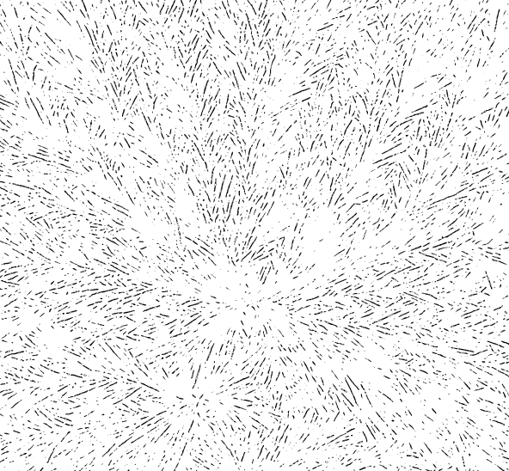 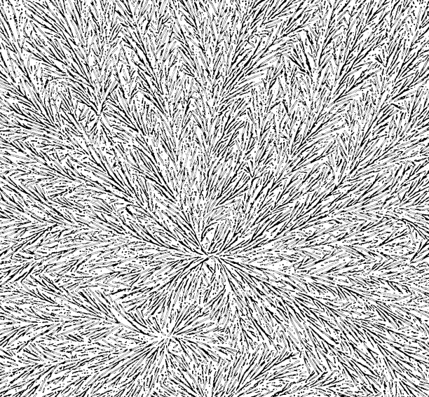

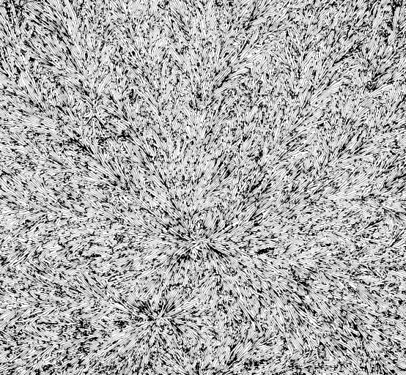

Black points are the points with singularity exponents. Hence we can obtain a detailed presentation of an image “by layers”. For each level set we calculate its fractal dimension , and obtain the set of fractal dimensions –multifractal spectrum.

Bean2

Alpha in [1.08,3.50]; step on alpha is 0.25

|  |  |
| --- | --- |
|  | mfs |
| 1.08 | 0.43 |
| 1.33 | 0.79 |
| 1.58 | 1.24 |
| 1.83 | 1.66 |
| 2.08 | 1.53 |
| 2.33 | 1.16 |
| 2.58 | 0.83 |
| 2.83 | 0.58 |
| 3.08 | 0.40 |
| 3.33 | 0.04 |

Bean3

Alpha in [1.15,3.42]; step on alpha is 0.25.

|  |  |
| --- | --- |
|  | mfs |
| 1.15 | 0.49 |
| 1.40 | 0.91 |
| 1.65 | 1.40 |
| 1.90 | 1.65 |
| 2.15 | 1.44 |
| 2.40 | 1.06 |
| 2.65 | 0.74 |
| 2.90 | 0.56 |
| 3.15 | 0.38 |
| 3.40 | 0.28 |

Bean4

Alpha in [1.25,3.08]; step on alpha is 0.25

|  |  |
| --- | --- |
|  | mfs |
| 1.25 | 0.54 |
| 1.50 | 1.04 |
| 1.75 | 1.59 |
| 2.00 | 1.67 |
| 2.25 | 1.20 |
| 2.50 | 0.76 |
| 2.75 | 0.50 |
| 3.00 | 0.26 |